**Non-Cisco Catalog Update Process**

*Uploading 4 mandatory Juniper catalogs, and catalogs from other non-Cisco vendors (HP, Avaya, Graybar). May need to manually edit/fix known data/format issues and make the catalog files ready to be scheduled to upload. Always first upload them in Stage and resolve issues (or get them resolved by vendor) if any, then only upload them in Production. Make sure every scheduled catalog is successfully uploaded.*

Steps to upload non-Cisco Vendor Catalog:

1. We have to do this once a month only. On or about the 3rd Monday of each month Pei Chang Huang will submit a ticket to load the Juniper bootstraps.

1. Unzip and open with Excel 2010:  
   For Catalog file (and for some Vendors, for Price file);
   1. Modify the column names to match template for the vendor:

|  |  |  |  |
| --- | --- | --- | --- |
| Template | | | |
| S.No | **Product** | **Catalog File** | **Price File** |
| 1. | **Juniper** |  |  |
| 2. | **Graybar** |  |  |
| 3. | **Avaya** |  |  |
| 4. | **HP** |  |  |

1. Match the format from the email to the one attached above and replace all line breaks (Alt + 010) with space “ “
2. Save file as pipe delimited (MS-DOS) CSV format. Do this for both catalog and price file.
3. Now convert all the 8 files and zip the file and send to Chang.
4. Once Chang confirms that all the files are uploaded in DEV environment upload all files in production environment.
5. Upload Catalog files using VPC
   1. Open VPC Prod Application using Firefox:  
      <http://attcpesales.web.att.com/VPC/faces/VPCHome>
   2. Click Catalog Upload tab

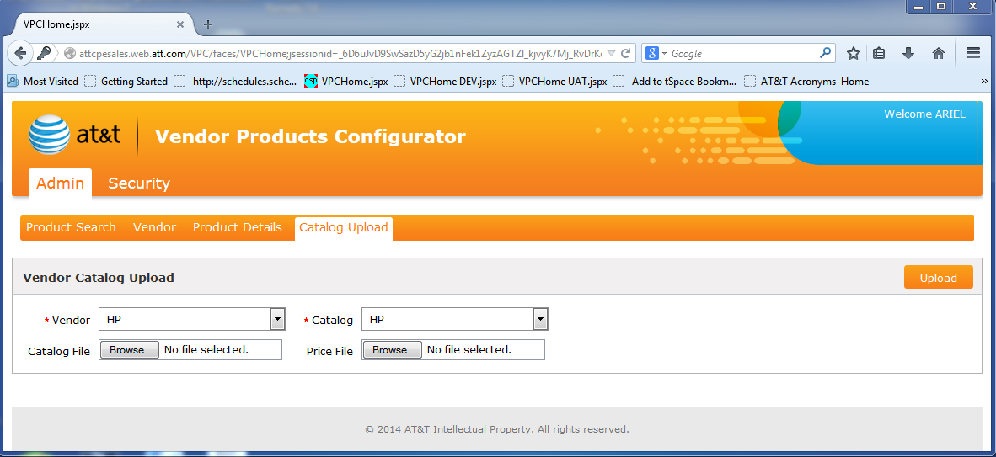

* 1. Select Vendor and Catalog from dropdowns
  2. Browser to Catalog file location, select file and wait for the wait-cursor to indicate upload is complete. Do same for Price File.  
     Note: You may have to wait for several minutes for completion, if the file size is in the 10’s of Mb’s.
  3. Click Upload and acknowledge Success popup.

1. Verify catalog files uploaded to SSDQ DB:
   1. Open connection to SSDQ [PROD or non-prod] DB
   2. **select * from vpc.MD_VENDOR_SSDQ_DATA order by created_dt desc;**
   3. **After uploading files check that it is successfully uploaded or not**

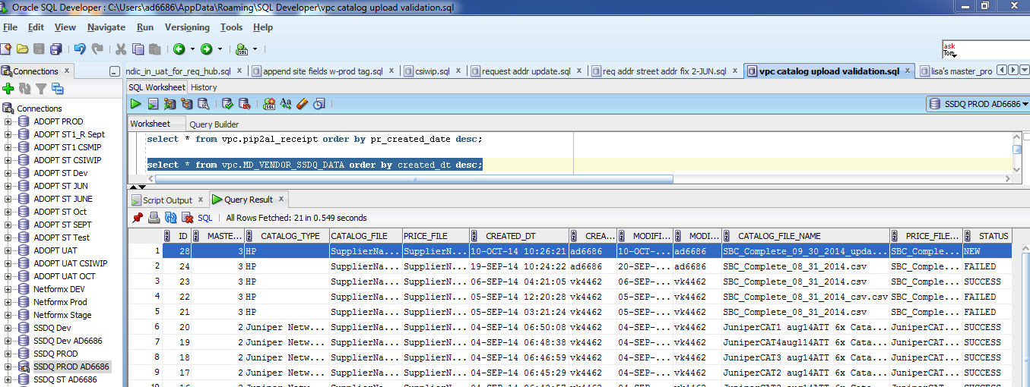

* 1. Confirm that Row 1 contains the uploaded catalog with status = NEW
     1. If Row 1 is valid, continue to Step 8
     2. If Row 1 is not valid
        1. delete the row, if it has a fault
        2. Go back to Step 6.

1. **Before uploading the catalog files make sure process status is C**

Check the VPC.VPC_INTERFACE_CONTROL.PROCESS_STATUS = ‘C’:  
select * from VPC.VPC_INTERFACE_CONTROL;-- where I – In Complete; C – Complete

* 1. If PROCESS_STATUS = ‘C’, continue to Step 9
  2. If PROCESS_STATUS = ‘I’

1. Once all the files are uploaded and shows success in DB inform Chang that its successfully completed.